Photo card booklet – Higher
Contents

Card | Sub-topic | Unit
A | Me, my friends and family | 1
B | Me, my friends and family
C | Me, my friends and family
D | Technology in everyday life | 2
E | Technology in everyday life
F | Technology in everyday life
G | Technology in everyday life
H | Technology in everyday life
I | Free time activities | 3
J | Free time activities
K | Free time activities
L | Free time activities
M | Customs and festivals | 3
N | Home, town, neighbourhood and region | 5
O | Home, town, neighbourhood and region
P | Social issues | 6
Q | Social issues
R | Global issues | 7
S | Global issues
T | Travel and tourism | 8
U | Travel and tourism
V | Travel and tourism
W | My studies | 9
X | Life at school and college | 10
Y | Education post-16 | 11
Z | Jobs, careers choices and ambitions | 12

HIGHER TIER

Card A Teacher’s Photo card.
- Look at the photo during the preparation period
- Make any notes you wish to an Additional Answer Sheet
- Your teacher will then ask you questions about the photo and about topics related to Me, my friends and family.
Your teacher will ask you the following three questions and then two more questions which you have not prepared.
- ¿Qué hay en la foto?
- ¿Es importante tener una buena relación con tu familia?
- ¿Discutes con tu madre?
- ! ¿Qué crees que es necesario para tener una buena relación con la familia?
- ! ¿Crees que es normal discutir con la familia? ¿Por qué?
HIGHER TIER

Card A Student’s Photo card.
- Look at the photo during the preparation period
- Make any notes you wish to an Additional Answer Sheet
- Your teacher will then ask you questions about the photo and about topics related to Me, my friends and family.
Your teacher will ask you the following three questions and then two more questions which you have not prepared.

- ¿Qué hay en la foto?
- ¿Es importante tener una buena relación con tu familia?
- ¿Discutes con tu madre?
- !
- !
HIGHER TIER

Card B Teacher’s Photo card.
- Look at the photo during the preparation period
- Make any notes you wish to an Additional Answer Sheet
- Your teacher will then ask you questions about the photo and about topics related to Me, my family and friends.
Your teacher will ask you the following three questions and then two more questions which you have not prepared.
- ¿Qué hay en la foto?
- ¿Tienes una familia grande?
- ¿Ves la televisión con tu familia?
- ! ¿Crees que las nuevas tecnologías son buenas para las relaciones con la familia?
- ! ¿Preferirías tener una familia grande o una pequeña?
HIGHER TIER

Card B Student’s Photo card.
- Look at the photo during the preparation period
- Make any notes you wish to an Additional Answer Sheet
- Your teacher will then ask you questions about the photo and about topics related to Me, my family and friends.
Your teacher will ask you the following three questions and then two more questions which you have not prepared.

- ¿Qué hay en la foto?
- ¿Tienes una familia grande?
- ¿Ves la televisión con tu familia?
- !
- !
HIGHER TIER

Card C Teacher’s Photo card.
- Look at the photo during the preparation period
- Make any notes you wish to an Additional Answer Sheet
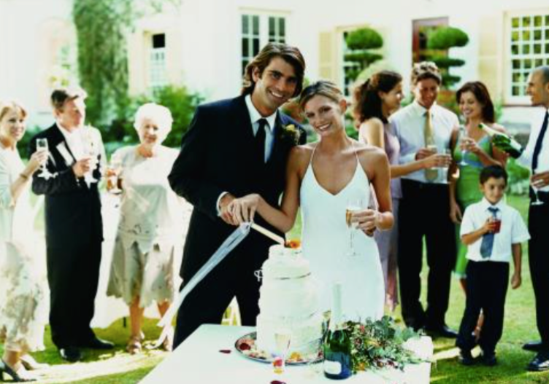
- Your teacher will then ask you questions about the photo and about topics related to Me, my family and friends.
Your teacher will ask you the following three questions and then two more questions which you have not prepared.
- ¿Qué hay en la foto?
- ¿Qué opinas del matrimonio?
- ¿Te gustaría casarte cuando seas mayor? ¿Por qué/por qué no?
- ! ¿El matrimonio es importante para ti? ¿Por qué?
- ! ¿Qué opines del divorcio?
HIGHER TIER

Card C Student’s Photo card.
- Look at the photo during the preparation period
- Make any notes you wish to an Additional Answer Sheet
- Your teacher will then ask you questions about the photo and about topics related to Me, my friends and family.
Your teacher will ask you the following three questions and then two more questions which you have not prepared.
- ¿Qué hay en la foto?
- ¿Qué opinas del matrimonio?
- ¿Te gustaría casarte cuando seas mayor? ¿Por qué/por qué no?
- !
- !
HIGHER TIER

Card D Teacher’s Photo card.
- Look at the photo during the preparation period
- Make any notes you wish to an Additional Answer Sheet
- Your teacher will then ask you questions about the photo and about topics related to Technology in everyday life.

Your teacher will ask you the following three questions and then two more questions which you have not prepared.

- ¿Qué hay en la foto?
- ¿Qué piensas de las nuevas tecnologías? ¿Por qué?
- ¿Con qué frecuencia utilizas las nuevas tecnologías?
- ! ¿Utilizas más el móvil o el ordenador?
- ! ¿Cuáles son las ventajas y desventajas de las nuevas tecnologías?
HIGHER TIER

Card D Student’s Photo card.
- Look at the photo during the preparation period
- Make any notes you wish to an Additional Answer Sheet
- Your teacher will then ask you questions about the photo and about topics related to Technology in everyday life.

Your teacher will ask you the following three questions and then two more questions which you have not prepared.

- ¿Qué hay en la foto?
- ¿Qué piensas de las nuevas tecnologías? ¿Por qué?
- ¿Con qué frecuencia utilizas las nuevas tecnologías?
- !
- !
HIGHER TIER

Card E Teacher’s Photo card.
- Look at the photo during the preparation period
- Make any notes you wish to an Additional Answer Sheet
- Your teacher will then ask you questions about the photo and about topics related to Technology in everyday life.
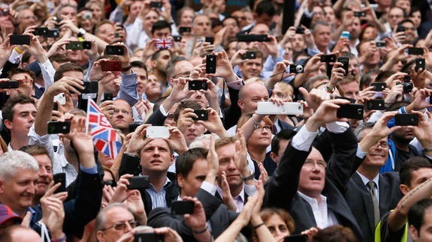

Your teacher will ask you the following three questions and then two more questions which you have not prepared.

- ¿Qué hay en la foto?
- ¿Qué piensas de las nuevas tecnologías? ¿Por qué?
- ¿De niño, cómo utilizabas las nuevas tecnologías?
- ! ¿Crees que las nuevas tecnologías son buenas para las relaciones sociales?
- ! ¿Son las nuevas tecnologías necesarias hoy en día?

HIGHER TIER

Card E Student’s Photo card.
- Look at the photo during the preparation period
- Make any notes you wish to an Additional Answer Sheet
- Your teacher will then ask you questions about the photo and about topics related to Technology in everyday life.

Your teacher will ask you the following three questions and then two more questions which you have not prepared.

- ¿Qué hay en la foto?
- ¿Qué piensas de las nuevas tecnologías? ¿Por qué?
- ¿De niño, cómo utilizabas las nuevas tecnologías?
- !
- !
HIGHER TIER

Card F Teacher’s Photo card.
- Look at the photo during the preparation period
- Make any notes you wish to an Additional Answer Sheet
- Your teacher will then ask you questions about the photo and about topics related to Technology in everyday life.

Your teacher will ask you the following three questions and then two more questions which you have not prepared.

- ¿Qué hay en la foto?
- ¿Qué piensas de las nuevas tecnologías? ¿Por qué?
- ¿Cuál es la solución para la dependencia de los aparatos portátiles?
- ! ¿Crees que las nuevas tecnologías son adictivas?
- ! ¿Con qué frecuencia utilizas tu móvil y para qué?

HIGHER TIER

Card F Student’s Photo card.
- Look at the photo during the preparation period
- Make any notes you wish to an Additional Answer Sheet
- Your teacher will then ask you questions about the photo and about topics related to Technology in everyday life.

Your teacher will ask you the following three questions and then two more questions which you have not prepared.

- ¿Qué hay en la foto?
- ¿Qué piensas de las nuevas tecnologías? ¿Por qué?
- ¿Cuál es la solución para la dependencia de los aparatos portátiles?
- !
- !

HIGHER TIER

Card G Teacher’s Photo card.
- Look at the photo during the preparation period
- Make any notes you wish to an Additional Answer Sheet
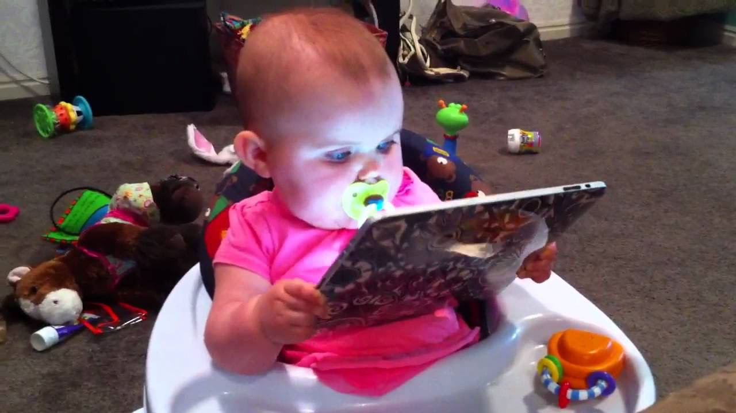
- Your teacher will then ask you questions about the photo and about topics related to Technology in everyday life.
Your teacher will ask you the following three questions and then two more questions which you have not prepared.

- ¿Qué hay en la foto?
- ¿Prefieres comprar un CD o descargar la música? ¿Por qué?
- ¿Cómo utilizabas internet cuando eras joven?
- ! ¿Crees que las nuevas tecnologías favorecen actividades peligrosas?
- ! ¿Qué son los aspectos buenos del internet?

HIGHER TIER

Card G Student’s Photo card.
- Look at the photo during the preparation period
- Make any notes you wish to an Additional Answer Sheet
- Your teacher will then ask you questions about the photo and about topics related to Technology in everyday life.
Your teacher will ask you the following three questions and then two more questions which you have not prepared.

- ¿Qué hay en la foto?
- ¿Prefieres comprar un CD o descargar la música? ¿Por qué?
- ¿Cómo utilizabas internet cuando eras joven?
- !
- !

HIGHER TIER

Card H Teacher’s Photo card.
• Look at the photo during the preparation period
• Make any notes you wish to an Additional Answer Sheet
• Your teacher will then ask you questions about the photo and about topics related to Technologies in everyday life.
Your teacher will ask you the following three questions and then two more questions which you have not prepared.

- ¿Qué hay en la foto?
- ¿Piensas que las redes sociales son útiles? ¿Por qué? ¿Por qué no?
- ¿Cuál es la ventaja de este tipo de comunicación?
! ¿Crees que hay que tener cuidado con las redes sociales?
! ¿Crees que los padres deberían controlar los ordenadores de sus hijos?

HIGHER TIER

Card H Student’s Photo card.
• Look at the photo during the preparation period
• Make any notes you wish to an Additional Answer Sheet
• Your teacher will then ask you questions about the photo and about topics related to Technology in everyday life.
Your teacher will ask you the following three questions and then two more questions which you have not prepared.

- ¿Qué hay en la foto?
- ¿Piensas que las redes sociales son útiles? ¿Por qué? ¿Por qué no?
- ¿Cuál es la ventaja de este tipo de comunicación?
!
!

HIGHER TIER

Card I Teacher’s Photo card.
- Look at the photo during the preparation period
- Make any notes you wish to an Additional Answer Sheet
- Your teacher will then ask you questions about the photo and about topics related to Free time activities
Your teacher will ask you the following three questions and then two more questions which you have not prepared.
- ¿Qué hay en la foto?
- ¿Qué tipo de películas te gusta ver? ¿Por qué?
- ¿Cuál fue la última película que viste?
- ! ¿Prefieres ir al cine o ver las películas en casa? ¿Por qué?
- ! ¿Cuáles son las ventajas e inconvenientes de ver películas en casa / ir al cine?
HIGHER TIER

Card I Student’s Photo card.
- Look at the photo during the preparation period
- Make any notes you wish to an Additional Answer Sheet
- Your teacher will then ask you questions about the photo and about topics related to Free time activities

Your teacher will ask you the following three questions and then two more questions which you have not prepared.
- ¿Qué hay en la foto?
- ¿Qué tipo de películas te gusta ver? ¿Por qué?
- ¿Cuál fue la última película que viste?
- !
- !
HIGHER TIER

Card J Teacher’s Photo card.
- Look at the photo during the preparation period
- Make any notes you wish to an Additional Answer Sheet
- Your teacher will then ask you questions about the photo and about topics related to Free time activities

Your teacher will ask you the following three questions and then two more questions which you have not prepared.
- ¿Qué hay en la foto?
- ¿Cuál es tu opinión de la música española?
- ¿Has ido a algún concierto recientemente?
- ! ¿Cuál es el cantante favorito de tu madre?
- ¡ ¿Qué música escuchan tus padres?

HIGHER TIER

Card J Student’s Photo card.
- Look at the photo during the preparation period
- Make any notes you wish to an Additional Answer Sheet
- Your teacher will then ask you questions about the photo and about topics related to Free time activities.

Your teacher will ask you the following three questions and then two more questions which you have not prepared.
- ¿Qué hay en la foto?
- ¿Cuál es tu opinión de la música española?
- ¿Has ido a algún concierto recientemente?
- !
- ¡
HIGHER TIER

Card K Teacher’s Photo card.
- Look at the photo during the preparation period
- Make any notes you wish to an Additional Answer Sheet
- Your teacher will then ask you questions about the photo and about topics related to Free time activities

Your teacher will ask you the following three questions and then two more questions which you have not prepared.

- ¿Qué hay en la foto?
- ¿Qué tipo de música te gusta escuchar? ¿Por qué?
- ¿Tocas algún instrumento?
- ! ¿Cuál es el tipo de música que más odias?
- ! ¿Qué tipo de música prefieres para bailar?

HIGHER TIER

Card K Student’s Photo card.
- Look at the photo during the preparation period
- Make any notes you wish to an Additional Answer Sheet
- Your teacher will then ask you questions about the photo and about topics related to Free time activities

Your teacher will ask you the following three questions and then two more questions which you have not prepared.
- ¿Qué hay en la foto?
- ¿Qué tipo de música te gusta escuchar? ¿Por qué?
- ¿Tocas algún instrumento?
- !
- !

HIGHER TIER

Card L Teacher’s Photo card.
• Look at the photo during the preparation period
• Make any notes you wish to an Additional Answer Sheet
• Your teacher will then ask you questions about the photo and about topics related to Free time activities

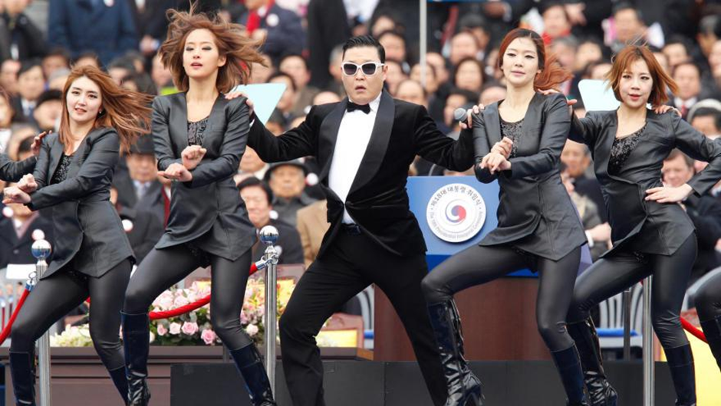
Your teacher will ask you the following three questions and then two more questions which you have not prepared.

- ¿Qué hay en la foto?
- ¿Te gusta ver a los cantantes en la televisión?
- ¿Crees que los cantantes también deberían bailar? ¿Por qué?
! ¿Puedes cantar y bailar a la vez?

! ¿Conoces a algún bailarín famoso?

HIGHER TIER

Card L Student’s Photo card.
• Look at the photo during the preparation period
• Make any notes you wish to an Additional Answer Sheet
• Your teacher will then ask you questions about the photo and about topics related to Free time activities.
Your teacher will ask you the following three questions and then two more questions which you have not prepared.

- ¿Qué hay en la foto?
- ¿Te gusta ver a los cantantes en la televisión?
- ¿Crees que los cantantes también deberían bailar? ¿Por qué?
!

!

HIGHER TIER

Card M Teacher’s Photo card.
- Look at the photo during the preparation period
- Make any notes you wish to an Additional Answer Sheet
- Your teacher will then ask you questions about the photo and about topics related to Customs and festivals.
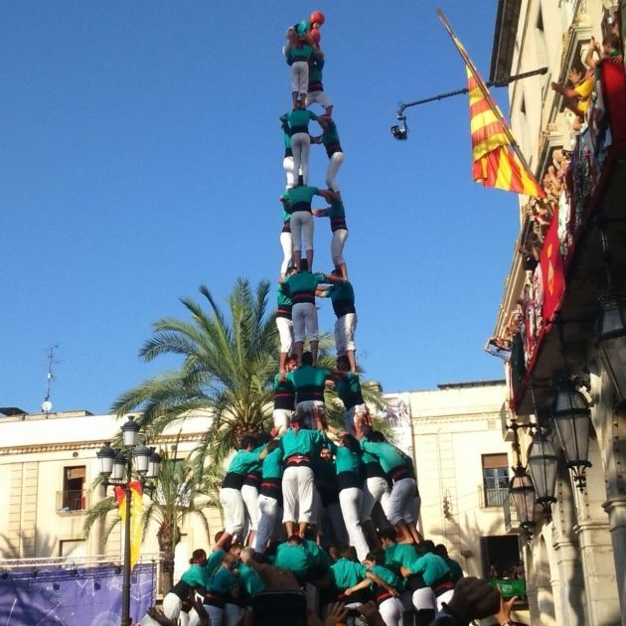
Your teacher will ask you the following three questions and then two more questions which you have not prepared.
- ¿Qué hay en la foto?
- ¿Fuiste alguna vez a una fiesta española? ¿Cómo era?
- ¿Qué piensas de la vida española?
- ! Compara la vida española y británica.
- ! ¿Qué son las horas normales de comer en España?

HIGHER TIER

Card M Student’s Photo card.
- Look at the photo during the preparation period
- Make any notes you wish to an Additional Answer Sheet
- Your teacher will then ask you questions about the photo and about topics related to Customs and festivals.
Your teacher will ask you the following three questions and then two more questions which you have not prepared.
- ¿Qué hay en la foto?
- ¿Fuiste alguna vez a una fiesta española? ¿Cómo era?
- ¿Qué piensas de la vida española?
- !
- !

HIGHER TIER

Card N Teacher’s Photo card.
- Look at the photo during the preparation period
- Make any notes you wish to an Additional Answer Sheet
- Your teacher will then ask you questions about the photo and about topics related to Home, town, neighbourhood and region.

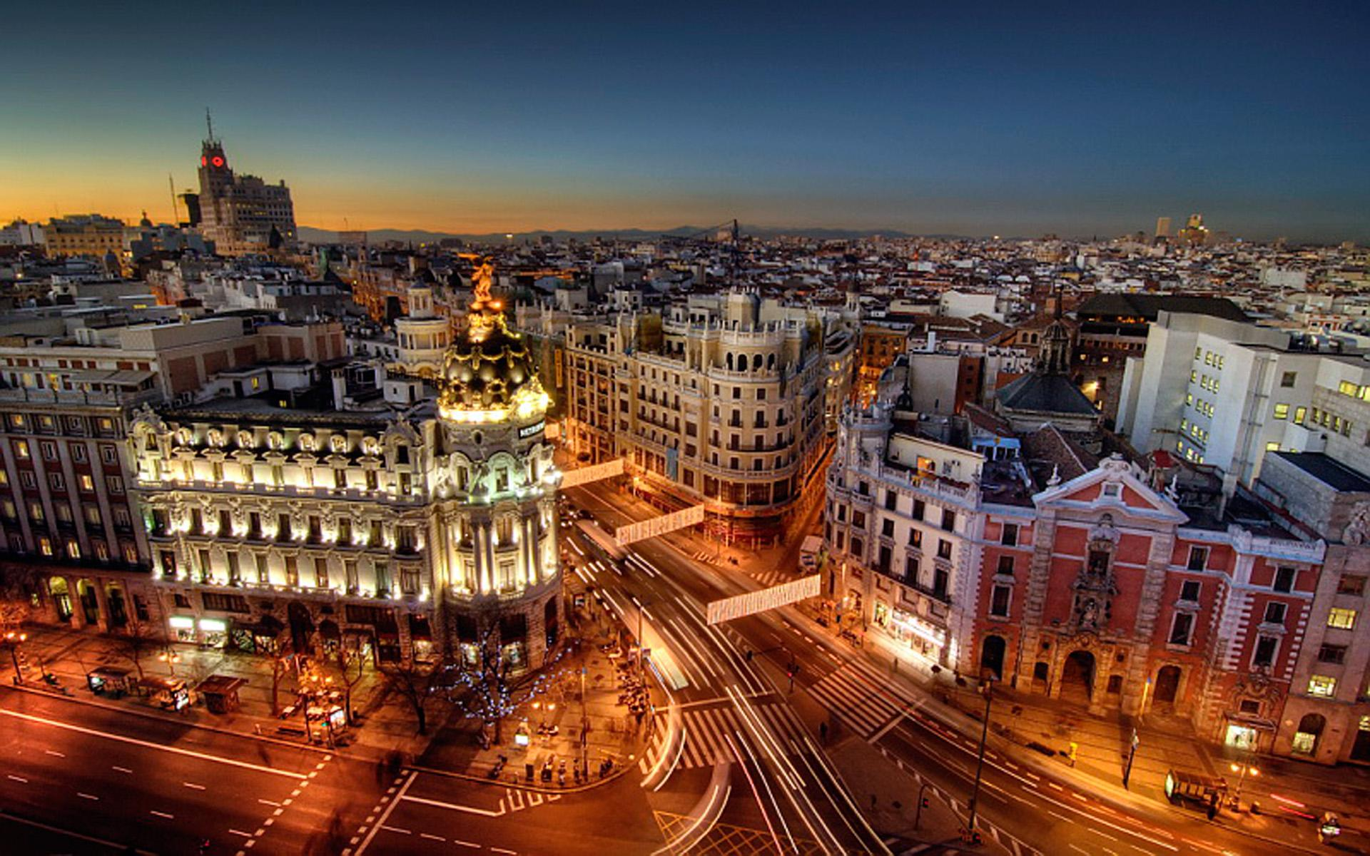

Your teacher will ask you the following three questions and then two more questions which you have not prepared.
- ¿Qué hay en la foto?
- ¿Cómo es tu pueblo?
- ¿Qué hay que hacer en tu pueblo para los jóvenes?
- ¿Cómo era tu pueblo de niño?
- ¿Qué sería tu pueblo ideal?
HIGHER TIER

Card N Student’s Photo card.
- Look at the photo during the preparation period
- Make any notes you wish to an Additional Answer Sheet
- Your teacher will then ask you questions about the photo and about topics related to Home, town, neighbourhood and region.

Your teacher will ask you the following three questions and then two more questions which you have not prepared.

- ¿Qué hay en la foto?
- ¿Cómo es tu pueblo?
- ¿Qué hay que hacer en tu pueblo para los jóvenes?
- !
- !
HIGHER TIER

Card O Teacher’s Photo card.
- Look at the photo during the preparation period
- Make any notes you wish to an Additional Answer Sheet
- Your teacher will then ask you questions about the photo and about topics related to Home, town, neighbourhood and region.

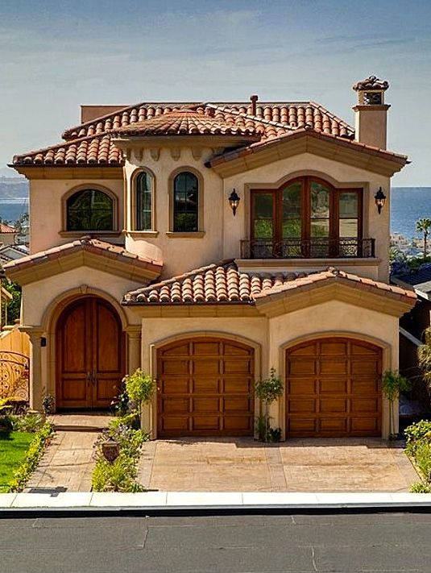

Your teacher will ask you the following three questions and then two more questions which you have not prepared.
- ¿Qué hay en la foto?
- ¿Cómo es tu casa?
- ¿Qué piensas de tu habitación? Descríbela
- ! ¿Qué hay cerca de tu casa?
- ! ¿Dónde te gustaría vivir en el futuro?

HIGHER TIER

Card O Student’s Photo card.
- Look at the photo during the preparation period
- Make any notes you wish to an Additional Answer Sheet
- Your teacher will then ask you questions about the photo and about topics related to Home, town, neighbourhood and region.

Your teacher will ask you the following three questions and then two more questions which you have not prepared.
- ¿Qué hay en la foto?
- ¿Cómo es tu casa?
- ¿Qué piensas de tu habitación? Descríbela
- !
- !

HIGHER TIER

Card P Teacher’s Photo card.
- Look at the photo during the preparation period
- Make any notes you wish to an Additional Answer Sheet
- Your teacher will then ask you questions about the photo and about topics related to Social issues

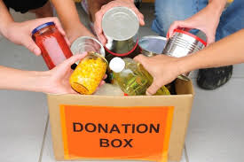
Your teacher will ask you the following three questions and then two more questions which you have not prepared.

- ¿Qué hay en la foto?
- ¿Te gustaría trabajar como voluntario? Por qué?
- ¿Qué hace un voluntario en una obra benéfica?
- ¿Si tuvieras mucho dinero, cómo ayudarías a las obras beneficias?
- ¿Participaste alguna vez en un evento de caridad?

HIGHER TIER

Card P Students’s Photo card.
- Look at the photo during the preparation period
- Make any notes you wish to an Additional Answer Sheet
- Your teacher will then ask you questions about the photo and about topics related to Social issues

Your teacher will ask you the following three questions and then two more questions which you have not prepared.

- ¿Qué hay en la foto?
- ¿Te gustaría trabajar como voluntario? Por qué?
- ¿Qué hace un voluntario en una obra benéfica?
- ¡
- ¡

HIGHER TIER

Card Q Teacher’s Photo card.
- Look at the photo during the preparation period
- Make any notes you wish to an Additional Answer Sheet
- Your teacher will then ask you questions about the photo and about topics related to Social issues

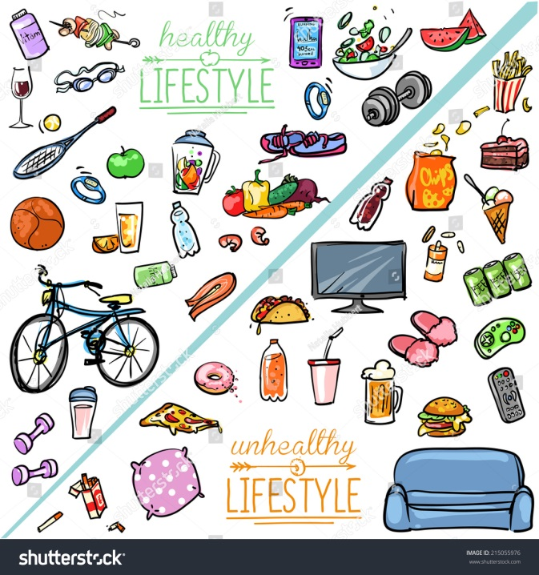
Your teacher will ask you the following three questions and then two more questions which you have not prepared.

- ¿Qué hay en la foto?
- ¿Crees que llevas una vida sana? Explica tu respuesta.
- ¿Qué es la importancia de llevar una vida sana?
- ¿Es importante que los jóvenes se mantengan en forma? Por qué?
- ¿Qué es el botellón? Explica lo que pasa y las consecuencias
HIGHER TIER

Card Q Students’s Photo card.
- Look at the photo during the preparation period
- Make any notes you wish to an Additional Answer Sheet
- Your teacher will then ask you questions about the photo and about topics related to Social issues

Your teacher will ask you the following three questions and then two more questions which you have not prepared.
- ¿Qué hay en la foto?
- ¿Crees que llevas una vida sana? Explica tu respuesta.
- ¿Qué es la importancia de llevar una vida sana?
- ¡
- ¡
HIGHER TIER

Card R Teacher’s Photo card.
• Look at the photo during the preparation period
• Make any notes you wish to an Additional Answer Sheet
• Your teacher will then ask you questions about the photo and about topics related to Global Issues.

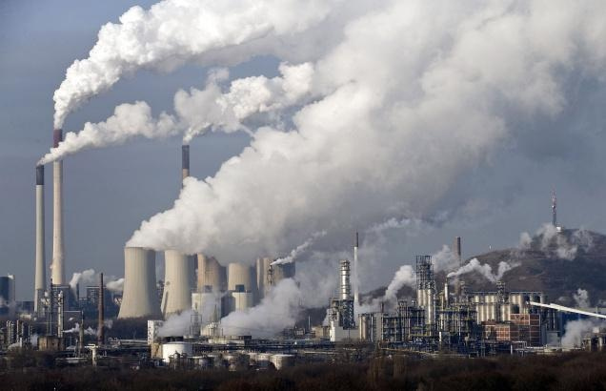
Your teacher will ask you the following three questions and then two more questions which you have not prepared.
- ¿Qué hay en la foto?
- ¿Qué haces para cuidar el medio ambiente?
- ¿Qué deberíamos hacer para cuidar el medio ambiente?
! ¿Qué crees que pasará si no hacemos nada para protegerlo?

! ¿Cuál es el problema más grave para el planeta y por qué?

HIGHER TIER

Card R Student’s Photo card.
• Look at the photo during the preparation period
• Make any notes you wish to an Additional Answer Sheet
• Your teacher will then ask you questions about the photo and about topics related to Global issues.

Your teacher will ask you the following three questions and then two more questions which you have not prepared.

- ¿Qué hay en la foto?
- ¿Qué haces para cuidar el medio ambiente?
- ¿Qué deberíamos hacer para cuidar el medio ambiente?
!

!
HIGHER TIER

Card S Teacher’s Photo card.
• Look at the photo during the preparation period
• Make any notes you wish to an Additional Answer Sheet
• Your teacher will then ask you questions about the photo and about topics related to Gloabal Issues.

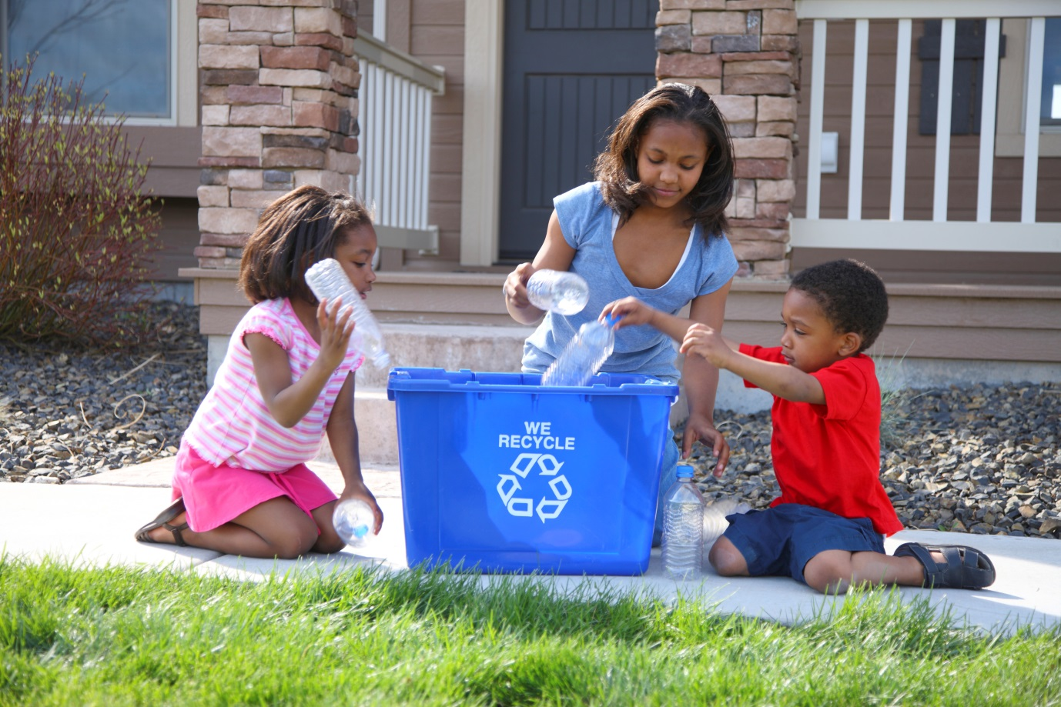
Your teacher will ask you the following three questions and then two more questions which you have not prepared.
- ¿Qué hay en la foto?
- ¿Qué te importa más$?$ ¿Reutilizar, reducir o reciclar?
- ¿Qué haces para reciclar?
! ¿Cuál es el problema medioambiental más grave en tu ciudad?

! ¿Qué cosas podemos reciclar?

HIGHER TIER

Card S Student’s Photo card.
• Look at the photo during the preparation period
• Make any notes you wish to an Additional Answer Sheet
• Your teacher will then ask you questions about the photo and about topics related to Global issues.

Your teacher will ask you the following three questions and then two more questions which you have not prepared.
- ¿Qué hay en la foto?
- ¿Qué te importa más$?$ ¿Reutilizar, reducir o reciclar?
- ¿Qué haces para reciclar?
!

!

HIGHER TIER

Card T Teacher’s Photo card.
• Look at the photo during the preparation period
• Make any notes you wish to an Additional Answer Sheet
• Your teacher will then ask you questions about the photo and about topics related to Travel and tourism.

Your teacher will ask you the following three questions and then two more questions which you have not prepared.
- ¿Qué hay en la foto?
- ¿A dónde vas de vacaciones normalmente?
- ¿Qué haces normalmente? ¿Te gusta?
! ¿A dónde vas a ir de vacaciones el año que viene?

! ¿Cómo serían tus vacaciones ideales?

HIGHER TIER

Card T Student’s Photo card.
• Look at the photo during the preparation period
• Make any notes you wish to an Additional Answer Sheet
• Your teacher will then ask you questions about the photo and about topics related to Travel and tourism.

Your teacher will ask you the following three questions and then two more questions which you have not prepared.
- ¿Qué hay en la foto?
- ¿A dónde vas de vacaciones normalmente?
- ¿Qué haces normalmente? ¿Te gusta?
!

!

HIGHER TIER

Card U Teacher’s Photo card.
• Look at the photo during the preparation period
• Make any notes you wish to an Additional Answer Sheet
• Your teacher will then ask you questions about the photo and about topics related to Travel and tourism.

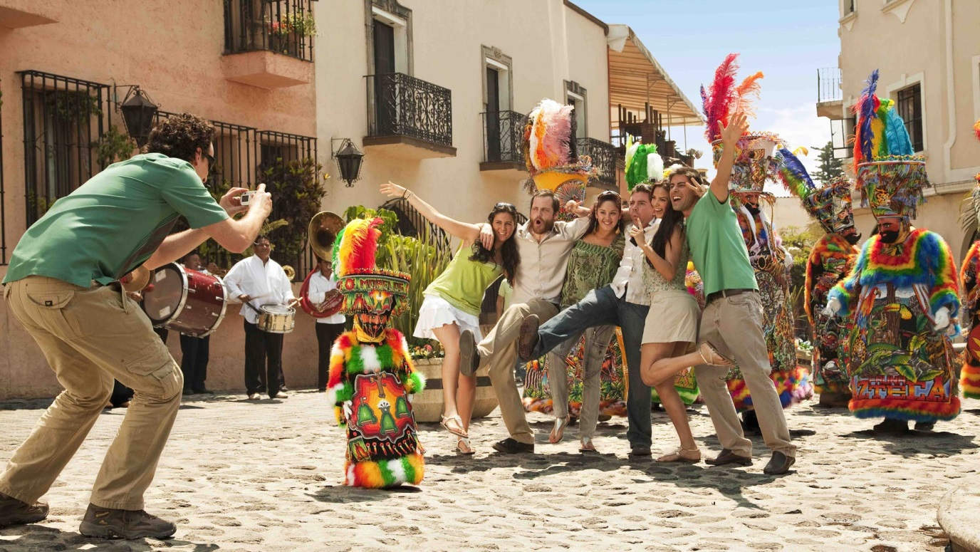
Your teacher will ask you the following three questions and then two more questions which you have not prepared.
- ¿Qué hay en la foto?
- ¿A dónde fuiste de vacaciones el año pasado?
- ¿Dónde te alojaste? ¿Cómo era?

! ¿Qué tal lo pasaste?

! ¿Si pudieras visitar algún país, cuál sería?

HIGHER TIER

Card U Student’s Photo card.
• Look at the photo during the preparation period
• Make any notes you wish to an Additional Answer Sheet
• Your teacher will then ask you questions about the photo and about topics related to Travel and tourism.

Your teacher will ask you the following three questions and then two more questions which you have not prepared.

- ¿Qué hay en la foto?
- ¿A dónde fuiste de vacaciones el año pasado?
- ¿Dónde te alojaste? ¿Cómo era?

!

!

HIGHER TIER

Card V Teacher’s Photo card.
• Look at the photo during the preparation period
• Make any notes you wish to an Additional Answer Sheet
• Your teacher will then ask you questions about the photo and about topics related to Travel and tourism.
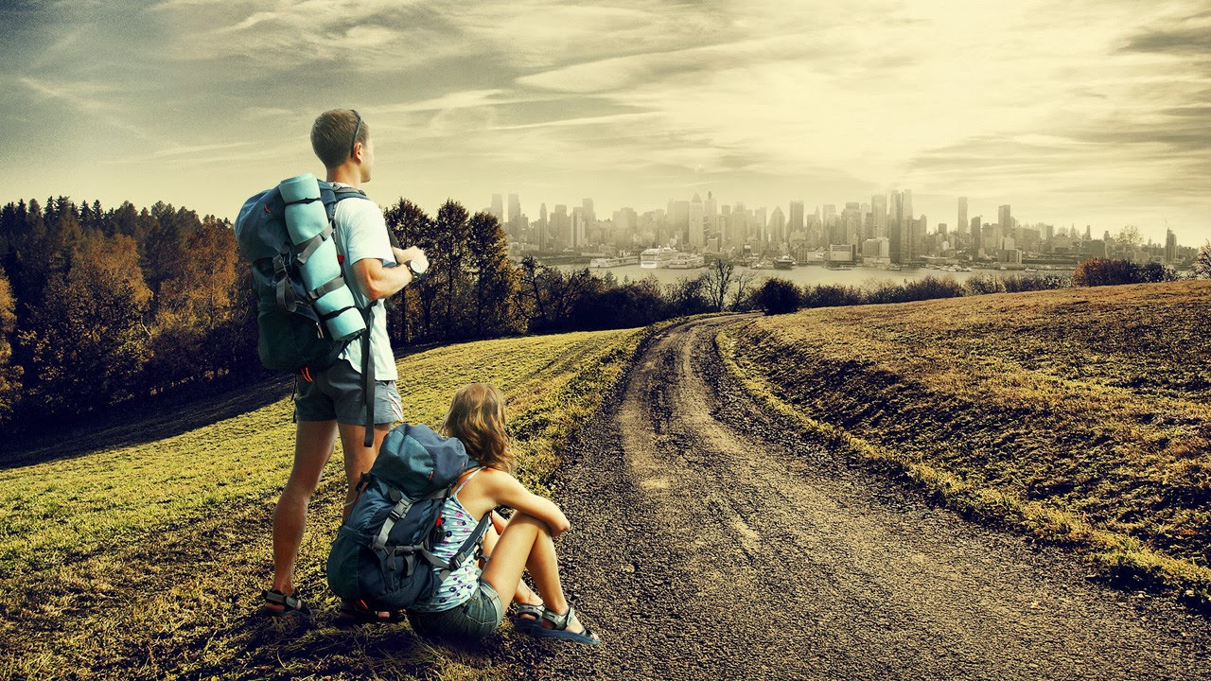

Your teacher will ask you the following three questions and then two more questions which you have not prepared.

- ¿Qué hay en la foto?
- ¿Crees que es importante viajar a otros países? ¿Por qué?
- ¿Qué países te gustaría conocer? ¿Por qué?
- ¿Si tuvieras mucho dinero, cómo serían las vacaciones ideales?
- ¿Te gustaría trabajar en el extranjero? Por qué?

HIGHER TIER

Card V Student’s Photo card.
• Look at the photo during the preparation period
• Make any notes you wish to an Additional Answer Sheet
• Your teacher will then ask you questions about the photo and about topics related to Travel and tourism.

Your teacher will ask you the following three questions and then two more questions which you have not prepared.
- ¿Qué hay en la foto?
- ¿Crees que es importante viajar a otros países? ¿Por qué?
- ¿Qué países te gustaría conocer? ¿Por qué?
- ¡
- ¡

HIGHER TIER

Card W Teacher’s Photo card.
• Look at the photo during the preparation period
• Make any notes you wish to an Additional Answer Sheet
• Your teacher will then ask you questions about the photo and about topics related to My studies

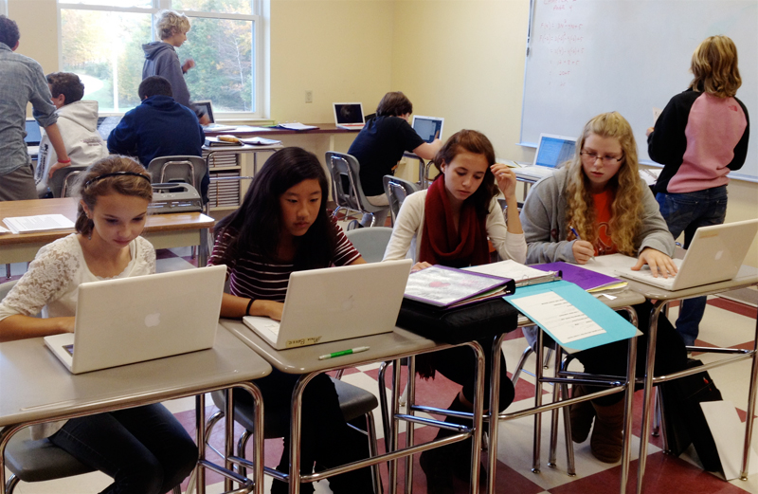
Your teacher will ask you the following three questions and then two more questions which you have not prepared.

- ¿Qué hay en la foto?
- ¿Qué tal tu instituto?
- ¿Cuál es tu asignatura favorita?
- ! ¿Cuál era tu asignatura favorita de niño/a?
- ! ¿Si fueras director, como sería tu instituto?
HIGHER TIER

Card W Student’s Photo card.
• Look at the photo during the preparation period
• Make any notes you wish to an Additional Answer Sheet
• Your teacher will then ask you questions about the photo and about topics related to My studies

Your teacher will ask you the following three questions and then two more questions which you have not prepared.

- ¿Qué hay en la foto?
- ¿Qué tal tu instituto?
- ¿Cuál es tu asignatura favorita?
- !
- !
HIGHER TIER

Card X Teacher’s Photo card.
• Look at the photo during the preparation period
• Make any notes you wish to an Additional Answer Sheet
• Your teacher will then ask you questions about the photo and about topics related to Life at school and college.

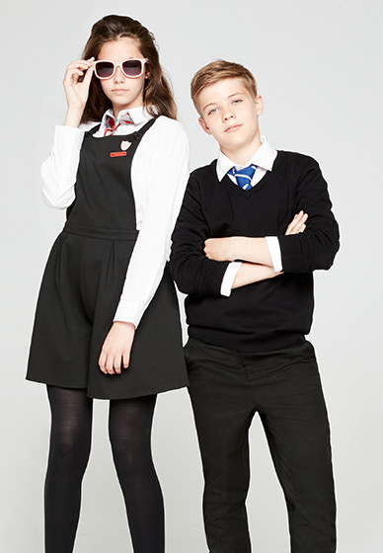
Your teacher will ask you the following three questions and then two more questions which you have not prepared.

- ¿Qué hay en la foto?
- ¿Cómo es tu uniforme?
- ¿Preferirías llevar tu propia ropa o el uniforme?

! Háblame de una regla buena en el instituto.

! ¿Qué es un aspecto negativo de tu instituto actual?

HIGHER TIER

Card X Student’s Photo card.
• Look at the photo during the preparation period
• Make any notes you wish to an Additional Answer Sheet
• Your teacher will then ask you questions about the photo and about topics related to Life at school and college.

Your teacher will ask you the following three questions and then two more questions which you have not prepared.

- ¿Qué hay en la foto?
- ¿Cómo es tu uniforme?
- ¿Preferirías llevar tu propia ropa o el uniforme?

!

!
HIGHER TIER

Card Y Teacher’s Photo card.
• Look at the photo during the preparation period
• Make any notes you wish to an Additional Answer Sheet
• Your teacher will then ask you questions about the photo and about topics related to Education post-16.

Your teacher will ask you the following three questions and then two more questions which you have not prepared.

- ¿Qué hay en la foto?
- ¿Quieres ir a la universidad o trabajar? ¿Por qué?
- ¿Cuándo seas mayor, qué te gustaría ser?

! ¿Te interesa hacer un aprendizaje? ¿Por qué?

! ¿Opinas que es importante ganar experiencia laboral?

HIGHER TIER

Card Y Student’s Photo card.
• Look at the photo during the preparation period
• Make any notes you wish to an Additional Answer Sheet
• Your teacher will then ask you questions about the photo and about topics related to Education post-16.

Your teacher will ask you the following three questions and then two more questions which you have not prepared.

- ¿Qué hay en la foto?
- ¿Quieres ir a la universidad o trabajar? ¿Por qué?
- ¿Cuándo seas mayor, qué te gustaría ser?

!

!

HIGHER TIER

Card Z Teacher’s Photo card.
• Look at the photo during the preparation period
• Make any notes you wish to an Additional Answer Sheet
• Your teacher will then ask you questions about the photo and about topics related to Jobs, career choices and ambitions

Your teacher will ask you the following three questions and then two more questions which you have not prepared.

- ¿Qué hay en la foto?
- ¿Le interesa usted trabajar en un hotel? ¿Por qué?
- ¿Se lleva bien usted con la gente en general? Da una razón.

! ¿Cuál es tu trabajo ideal?

! ¿Por qué te gustaría hacer este trabajo?
HIGHER TIER

Card Z Students’ Photo card.
• Look at the photo during the preparation period
• Make any notes you wish to an Additional Answer Sheet
• Your teacher will then ask you questions about the photo and about topics related to Jobs, career choices and ambitions
Your teacher will ask you the following three questions and then two more questions which you have not prepared.

- ¿Qué hay en la foto?
- ¿Le interesa usted trabajar en un hotel? ¿Por qué?
- ¿Se lleva bien usted con la gente en general? Da una razón.

!

!

