Session 11: Mindful Attention Awareness Scale

Complete the collection of statements about your everyday experiences. Using the 1-6 scale below, indicate how frequently or infrequently you currently have each experience. Answer according to what really reflects your experience rather than what you think your experience should be.
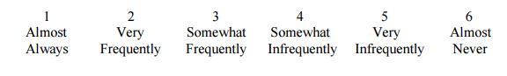
- I could be experiencing some emotion and not be conscious of it until sometime later. | 1 2 3 4 5 6
- I break or spill things because of carelessness, not paying attention, or thinking of something else. | 1 2 3 4 5 6
- I find it difficult to stay focused on what's happening in the present | 1 2 3 4 5 6
- I tend to walk quickly to get where I'm going without paying attention to what I experience along the way. | 1 2 3 4 5 6
- I tend not to notice feelings of physical tension or discomfort until they really grab my attention. | 1 2 3 4 5 6
- I forget a person's name almost as soon as I've been told it for the first time. | 1 2 3 4 5 6
- It seems I am "running on automatic," without much awareness of what I'm doing. | 1 2 3 4 5 6
- I rush through activities without being really attentive to them. | 1 2 3 4 5 6
- I get so focused on the goal I want to achieve that I lose touch with what I'm doing right now to get there. | 1 2 3 4 5 6
- I do jobs or tasks automatically, without being aware of what I'm doing. | 1 2 3 4 5 6
- I find myself listening to someone with one ear, doing something else at the same time. | 1 2 3 4 5 6
- I get to places on "automatic pilot" and then wonder how I got there. | 1 2 3 4 5 6
- I find myself preoccupied with the future or the past | 1 2 3 4 5 6
- I find myself doing things without paying attention | 1 2 3 4 5 6
- I snack without being aware that I'm eating. | 1 2 3 4 5 6

