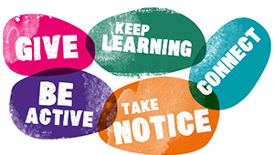
Complete each section of the worksheet by answering the questions which relate to each one.

Connect

Who can you go to for support in different areas of your life? – E.g. parents, teachers and peer groups.
Be Active

What can you do every day to be more active?

Take Notice

What strategies can you do to deal with the stresses in your life? How could you support others as well?
Keep Learning

What new things would you like to learn about? How could you achieve this?
Give

How could you do something for someone else?
Connect
Have people around you, connect with others in your life. Building these connections can support and enrich your life every day.

Be Active
Find a physical activity that you enjoy, exercising can make you feel good.

Take Notice
Be aware of the world around you and what you are feeling. Reflect on your experiences.

Keep Learning
Learn something new. Set yourself a new challenge that you will enjoy achieving.

Give Seeing yourself and your happiness as linked to the wider community can be incredibly rewarding and creates connections with the people around you.

