Task 1) Watch the video ‘How Habits Change Your Brain’ and answer the questions:
Question 1 - True or False. Habits are done automatically, without thinking.
Question 2 - Complete the sentence. New neural pathways (habits) are formed by consciously r________ a behaviour.
Question 3 - Claude Hopkins stated that habits have three key ingredients. Circle them from the list below:
Manifestation Cue Thought Deflection Behaviour Manner Reward
Question 4: Complete the sentence.
_______ a behaviour can help create a _______ and this is what makes a habit so _________.
Question 5:
Why do you get cravings?
Question 6 - complete the sentence:
When a behaviour is repeated often enough…
Task 2) complete The Energy Line below for everything you have to do this week including school life, work life and your personal life.
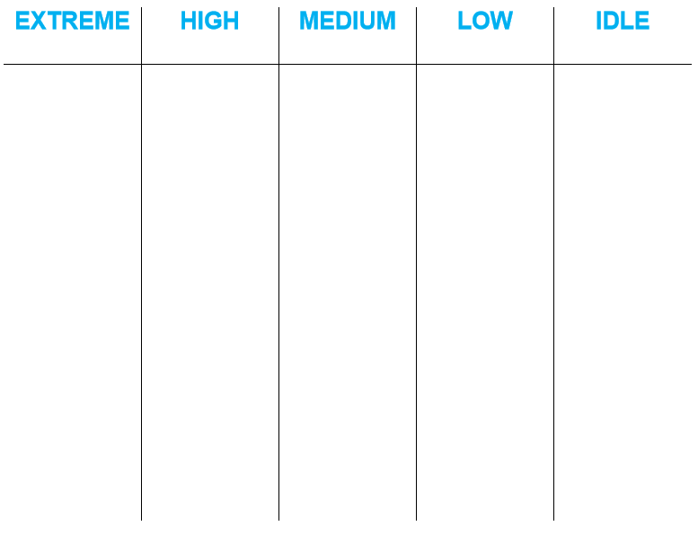

Task 3) complete The Eisenhower Matrix with all of the tasks on your to-do list this week.
