September 2018

Dear Parent/Guardian,

RELIGIOUS EDUCATION SYLLABUS – YEAR 8

In order to support your child’s progress in Religious Education, we would like to make you aware of the syllabus that they will be studying this year.

Please find below a breakdown of their course for this year.

Year 8 Religious Education Syllabus
Term Date | Autumn 1 | Autumn 2 | Spring 1 | Spring 2 | Summer 1 | Summer 2
Unit Name | The Bible  Prophets | Jesus as the Son of God | Justice and Peace | Catholic Social Teaching | Hinduism | Islam

If you would like to know more about the syllabus they will be studying, please visit the school website:

http://www.st-josephs.slough.sch.uk/?page_id=3105

Thank you so much for all of your support. If you have any questions or queries regarding your child’s Religious Education, please do not hesitate to contact me.

Yours sincerely,
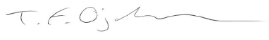

Mr T Ojakovoh
Head of Religious Education

