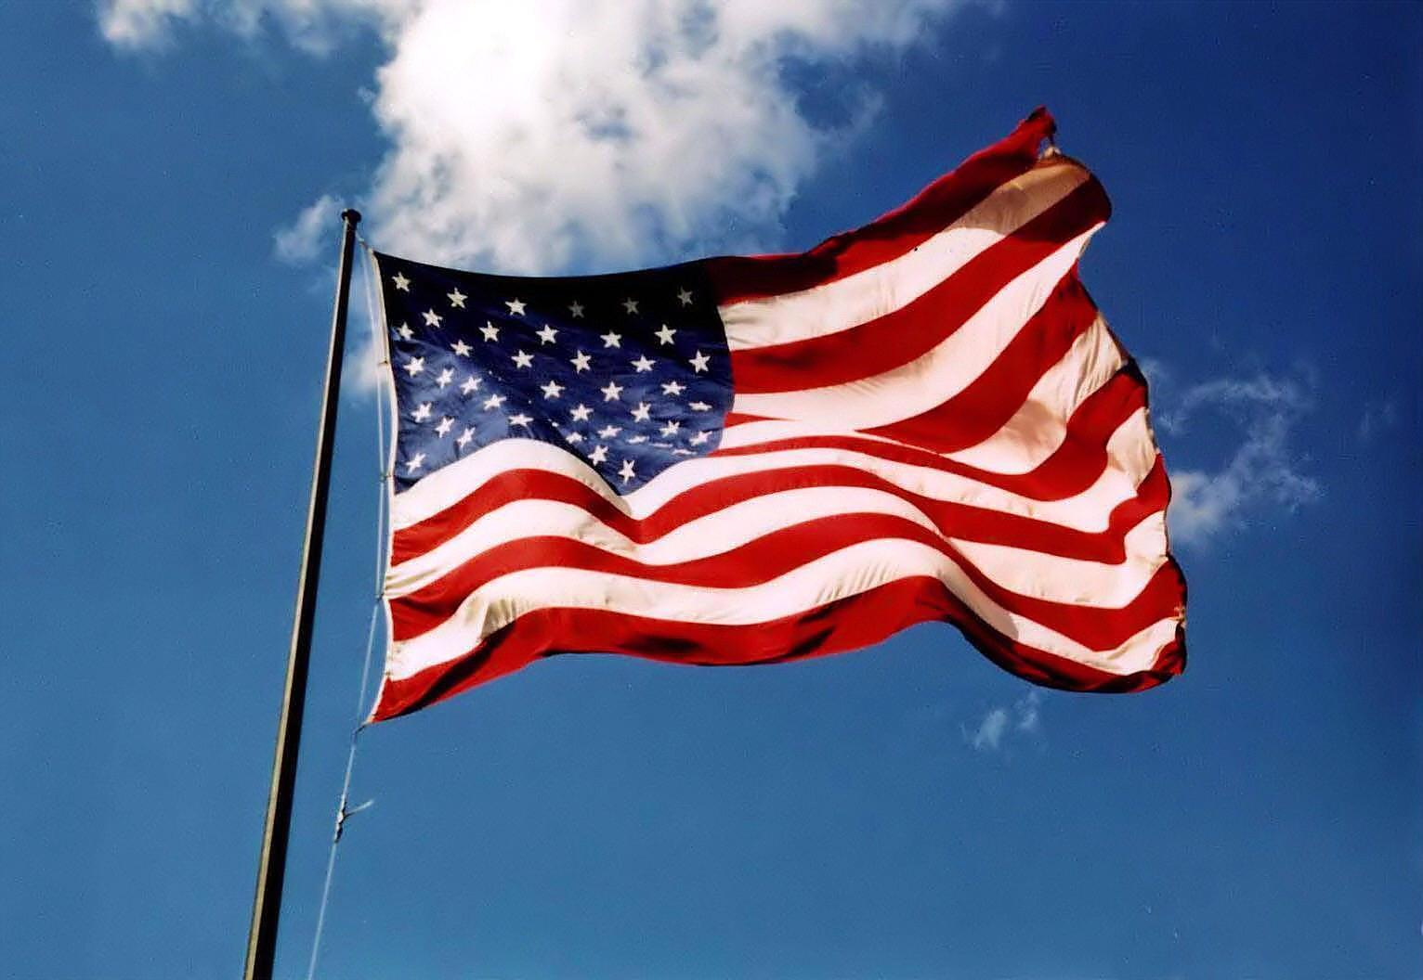

In search of the American Dream 1917-1996: A thematic study
History Department Transition Work.
Name………………………………………………………………………..

The USA pre 1900
The History of the USA is relatively recent. Following their independence from Great Britain in1783, Americans began to settle into their new continent with amazing speed. By the mid nineteenth century they had gained all land south of Canada and north of Mexico between the Atlantic and Pacific Oceans. This was achieved mainly through purchase and warfare.
The land mass was 3,022,000 square miles, in contrast with 94,525 square miles of the UK. It was settled so quickly that by 1890 the Census declared there was no longer any underdeveloped territory available for settlement.
The entire history of the USA until 1920 had happened in a space of 140 years. There was little time for development of tradition as there had been in Europe. The individual was thought to be of vast importance and the continent of America was there to be settled quickly. The fact that it was settled so quickly and the country developed so rapidly led many people to believe in the ‘American Dream’; that with hard work and initiative one could achieve anything without expecting much support from the government.
The USA was a land rich in natural resources, fertile for crops and populated by an energetic, dynamic people who were mainly descended from immigrants. The 19C had seen the biggest migration in history with millions leaving the old world of Europe and Asia and headed to America to find work, land and freedom from persecution. The USA was originally made up of immigrants who had arrived not willingly but often forcibly as slaves from Africa. The Civil war had torn the union apart in the years 1861-5. It had ended slavery but not the persecution of African Americans. The North had grown increasingly wealthy from industrial development, while the south had remained predominantly rural. The West was populated in mythology by pioneers who had tamed a wilderness largely by their own efforts. It had developed as a region of fierce independence with little toleration of government interference.
The USA had an economic structure in which people were free to make money with very little government interference. Industries grew wealthy because of three main factors:
- The relative abundance and cheapness of natural resources
- The availability of cheap, often immigrant labour
- The overwhelming demand in a continent developing so quickly.
Huge industrial concerns grew up in the great cities; but small scale industry also thrived.
Complete the following three tasks using the information on the USA pre 1900. Do the tasks in the booklet.
Task one
True or false – is the following information true or false? If false please correct it.
Information | True/false
America gained independence from Britain in 1873
America was able to gain empire quickly
America was bigger the Great Britain
By 1890 there was no land available for settlement
American people did not expect or want government intervention
The American dream was about hard work and initiative
America was mainly made of immigrants
The Civil War lasted from 1860-64
The Civil War ended slavery in America and persecution of blacks
Taxes were kept low to encourage industry

Task two - define the following key words
Word | Meaning
Census
Government intervention
American Dream
Civil War
Slavery
Immigrant
Industrial
Rural
persecution

Task three - Your teacher has written an essay describing America pre 1900. They are very proud of this, however they may have made some mistakes. Read through, find the errors and correct them.
America is a relatively new country. They had been part of the British Empire and used for transportation but in 1783 they gained independence. By the 1850s they had taken over all of Canada and Mexico by buying them and through war. America soon became an attractive country with many people wanting to move there; the census of 1790 stated that there was no more room for settlement and immigration was decreased. Even so lots of people still wanted to move there because of the American Dream – the idea that if you worked hard and took matters into your own hands the government would support you and would give you advice. The government also believed in low taxes for business owners. Another reason to move to America in the 1900s was because of the end of the Civil War, The majority of Americans were pleased that in 1865 slavery was abolished and that America was now not a racist country. A good example of this was that the KKK died down. There were three reasons for American economic prosperity. Firstly the fact the America had few natural resources meant that initiative was needed to create good and there were lots of opportunities. Secondly the amount of immigrants led to cheap labour and lastly the demand for goods.
Correct the mistakes your silly History teacher has made in this essay.
1.
2.
3.
4.
5.
6.
7.
8.

If you have any questions about America pre 1900 please write them here for your History teacher to answer.

The government of the USA is split into three sections.

- Legislature – The group of people that make the laws and change existing laws
- Executive - The branch in charge of enforcing the laws
- Supreme Court - Responsible for interpreting the laws and deciding if they are fair

Please go to the following website address
http://news.bbc.co.uk/1/shared/spl/hi/americas/04/us_election/govt_system/html/introduction.stm

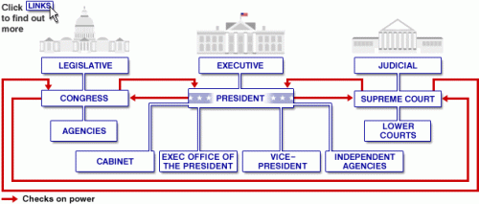
Use the above diagram on the BBC website. Click on the links for each section and answer the following questions.
- Which sections of the US government come under the control of the legislative branch?
…………………………………………………………………………………………………………………………………………………………………………………………………………………………………………………………………………………………………………………………………………………………………………………………………………………………………………………………………………………………………………………………………………………………………………………………………………
- What are the responsibilities of these two agencies?
………………………………………………………………………………………………………………………………………………………………………………………………………………………………………………………………………………………………………………………………………………………………………………………………………………………………………………………………………………………………………………………………………………………………………………………………………….
- In addition to leading the Executive branch of government what other responsibilities does the President have?
………………………………………………………………………………………………………………………………………………………………………………………………………………………………………………………………………………………………………………………………………………………………………………………………………………………………………………………………………………………………………………………………………………………………………………………………………..
- How many different sections does the President have direct control over?
………………………………………………………………………………………………………………………………………………………………………………………………………………………………………………………………………………………………………………………………………………………………………………………………………………………………………………………………………………………………………………………………………………………………………………………………………….
- Define and give two examples of external agencies
…………………………………………………………………………………………………………………………………………………………………………………………………………………………………………………………………………………………………………………………………………………………………………………………………………………………………………………………………………………………………………………………………………………………………………………………………………
- What is the Supreme Court? How is it organised?
…………………………………………………………………………………………………………………………………………………………………………………………………………………………………………………………………………………………………………………………………………………………………………………………………………………………………………………………………………………………………………………………………………………………………………………………………………
- Why are there lower courts as well as the Supreme Court?
.........................................................................................................................................................................................................................................................................................................................................................................................................................................................................................
Write definitions of the following key words. Once you have completed that, label the boxes on pages 7 and 8 with the correct key term (you will not need all the words from the key terms table)

This is a power held by the US President. The President can use this power to block any laws or proposals made by congress that he doesn’t like. It is only used in exceptional circumstances though.
These are organisations that represent the rights of workers. They campaign for better working conditions for their members. Members of these organisations are often left wing. These organisations are often disliked by the owners of big businesses.
These are organisations that represent the rights of workers. They campaign for better working conditions for their members. Members of these organisations are often left wing. These organisations are often disliked by the owners of big businesses.
……. Wing
In politics you can be either left wing, right wing or in the middle. People on this ‘wing’ believe in greater equality. They think that people should pay high taxes so that money can be shared more equally, they think workers deserve good rights and fair treatment and they are usually (although not always) anti-war. They also believe that large industries (like electricity or the railways should be owned by the government). People on this wing who are moderate are called ‘socialists’. People who believe very, very strongly in this wing are called ‘Communists’ or ‘Marxists’.

This is a political ideology. It is currently the ideology that is in existence in the UK and the USA. It advocates that people should be free to make money, and that companies should be protected by the government and the rule of law. It gives people great freedom, but also, if unchecked, can lead to great inequality.
A country that has a federal system has power divided between government and the regions. For example, there would be one national government that makes laws for the entire country, and separate regional parliaments that make laws for the different regions.

This is the belief in complete equality. People who hold this belief believe that rich people should have their money confiscated, that it should be illegal to own businesses or private property and that the working classes should be in charge of the country. This is an extreme left wing belief.
………. Wing
In politics you can be either left wing right wing or in the middle. People on this ‘wing’ believe in inequality. They think that people should be free to make lots of money and if people are unsuccessful then it is their own fault. For this reason they do not like high taxes. People on this wing are also very patriotic and believe in a strong country and army. They also hate communists and dislike socialists. People who are moderate on this wing are called ‘nationalists’. People who believe in these things very, very strongly are called ‘fascists’.
This one of the main political parties in the USA. This party was traditionally the party of big business and Western farmers. This party was the party of Abraham Lincoln, so was traditionally associated with anti-slavery and so most black people usually voted for this party. This changed between the 1930s and 1960s though as black people began supporting the Democratic party Southern whites supported the Republicans.
This is the most important arm of the judiciary in the USA. The Court is made up of nine senior judges, appointed by the President, who serve for life. They have the power to decide whether or not laws are constitutional. If the court decides that a law is unconstitutional, then the law cannot be enacted.

This is one of the main political parties of the USA. This party was traditionally the more ‘left wing’ and ‘liberal’ of the two parties.
This is the US equivalent of the British Parliament. They debate and approve new laws.
This is a fancy word to describe those who make the laws in a country. The Judges, the lawyers and the justice system.
These are organisations that represent the rights of workers. They campaign for better working conditions for their members. Members of these organisations are often left wing. These organisations are often disliked by the owners of big businesses.
These are organisations that represent the rights of workers. They campaign for better working conditions for their members. Members of these organisations are often left wing. These organisations are often disliked by the owners of big businesses.
These are organisations that represent the rights of workers. They campaign for better working conditions for their members. Members of these organisations are often left wing. These organisations are often disliked by the owners of big businesses.

America quick quiz
- The capital of America is
New York Washington New Orleans

- How many original English colonies were established?
11 12 13

- The currency in America is
The dollar the pound the euro

- Who was president of America during the great depression of 1929 – 1933?
Herbert Hoover Franklin Roosevelt Adolf Hitler

- What natural resources did America have in the 19C?
Coal and gold Coal and oil Oil and gold

- What was prohibition?
Making alcohol highly taxed removing taxes from alcohol making alcohol illegal?

- What percentage of alcohol did a drink have to contain for it to be defined as alcohol after prohibition?
1.0% 0.25% 0.5%

- The American Civil War made what illegal?
Alcohol drugs slavery

- How many branches of the government in the USA are there?
1 2 3

- What is the land mass of the USA
2,022,000 3,022,000 4,022,0000

Films as Evidence.

Watch at least one of the following films:

Gangs of New York (2002) Hidden Figures (2016) JFK (1991)
Little Women (1994) Selma (2014) The Butler (2013)
12 Years a Slave (2013) All the president’s men (1972)
Lincoln (2012) Thirteen Days (2000) The Great Gatsby (2013)
Cold Mountain (2003) Malcolm X (1992) Forrest Gump (1994)

Write a summary about it in the box underneath concentrating on what you learned about AMERICAN HISTORY
Please do not just copy a review from online –we will know if you do. We are looking for the use of film as evidence and what you can learn rather than story line or cinematography.

Key Words
WASP
USSR
Communist
Totalitarian
Cold War
Republicans
Democrats
Separation of powers
Congress
Tariffs
League of Nations
The Great Depression
Hire purchase
Laissez – faire
Anarchist
Ku Klux Klan
Wall Street Crash
HUAC
Deep South
Positive discrimination
UN
Space Race
GNP (Gross National Product)
Grooks
Hispanic American
Segregation
Lynching
14th Amendment
NAACP
CORE (Congress of Racial Equality)
Fellowship of Reconciliation
Lunch counter
Ghetto
Extension (in relation to the legal system)
Termination (in relation to the Native Americans)
Bracero programme
Operation Wetback (1953 – 58)
Proposition 6 (1978)
Speakeasy
Deportation
Melting pot
Boll weevil
Dividend
Bull market
Buying on the margin
The Federal Reserve Board (Fed)
Bear market
Money supply
Stagflation
Consumer Price Index (CPI)
Big Government
Monopolise
Supply-side theory
Constant 1987 dollars (or in 1987 dollars)
Real disposable personal income
Real GNP
Data series
Per capita income
Gross domestic product
Marginal income tax
Deregulation
Conglomerate
Savings and Loan Institution (S&L)
Capping
Foreclosure
Tractorcade
“Dual economies”

Topics for Wider Research

- Recordings of Roosevelt’s fireside chats
- Communist Manifesto
- Truman’s “Truman Doctrine” speech
- Eisenhower’s “Domino Theory” speech
- Who was Thurgood Marshall (1908 – 93)?
- What was the voluntary relocation programme (1952)?
- The Black Power Mixtape 1967 – 1975 documentary
- Recordings of speeches on Martin Luther King, Malcolm X, Stokely Carmichael, Russel Means (Native American rights), Cesar Chavez (Hispanic American rights), and Harvey Milk (gay rights).
- BBC People’s Century: Episode 6, Great Escape, looks at Hollywood in the 1920s.
- Google search on “Great Society” will find the text of President Johnson’s speech introducing his welfare reforms and film footage
- The Fire This Time documentary that considers the problems that led to the inner city riots in Los Angeles.
- BBC, People’s Century, Episode 26, Reaganism
- Create a timeline of each president from 1917 - 1993

