South Africa, 1948–94: from apartheid state to ‘rainbow nation’

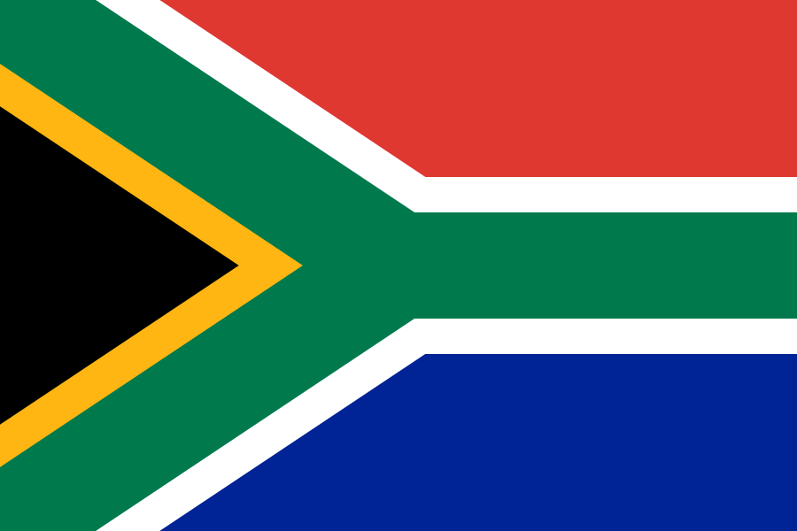
Edexcel Route F Searching for rights and freedoms in the twentieth century.

Name ……………………………………………………………

South Africa facts: How much do you know?
- The first European settlers came to South Africa in
1652 1784 1948

- The first European settlers in South Africa were
Welsh French Dutch

- The first settlers were called
South Africans Afrikans Boers

- The first settlers made their living by
Farming Weaving Dog breeding

- The first settlers lived with the Khoi people. The two groups:
Lived peacefully together Fought Went dancing

- What was the language the white settlers developed called?
African Afrikaans Shona

- What year did the British come to South Africa?
1766 1786 1796

- The British:
Took over the Government left South Africa Developed Apartheid

- The greatest event in the white settlers history was:
Finding South Africa The Boer War The Great trek

Read the following information then check if your answers were correct on the quiz.
The Dutch began to farm the land and become known as Boers which means farmers. There were Africans called Khoi living around but we drive them off the land. If they didn’t go we killed them or they became our servants.
European ships on their way to East Africa, India or the East Indies sailed had sailed around the Cape of Good Hope (South Africa) for many years. Some sailors had landed for fresh water supplies but the first white people to settle were the Dutch in 1652 led by James van Riebeck

Some farmers began to move away from the coast. This was called the Great Trek because they were trekking with all their belongings in a cart pulled by Oxen.

The British came to South Africa in 1795 and took over the government of the Cape from 1806.
By the mid eighteenth century the settlers had lost touch with Europe. They were living about 1-2 months journey by wagon from Cape Town. They had developed their own language - Afrikaans Dutch mixed with African and other words.

The Great Trek was hard. It was led by Piet Retief who was killed by the Zulus in the Battle of Blood River. The Boers used their wagons and organised them into a cirlcle called a laager and successfully defeated the Zulus.
In 1836 the Great Trek happened. This was the biggest event in Boer History. They were moving to escape British rule. On of things they didn’t like under British rule was the abolition of slavery in 1834.

Read the following information about Black People in South Africa and use it to complete the tasks on the following page.
The original inhabitants of South Africa were living in the Cape area 3,000 years ago. There were two groups, the SAN (called bushmen by whites) who were hunter gatherers and the KHOI who were herders of sheep and goats. The San no longer exist because of an uprising with the Khoi but also because they fell to white diseases and became little more than slaves on white farms.
Between about AD300 and AD1000 black people from further north in Africa arrived in the east and north of South Africa. They were more technologically advanced than the San and the Khoi and could make tools from iron and jewellery from gold. They were made up of many ethnic groups, spoke different languages nut did have trading routes between them. They also herded cattle, grew crops and owned their land collectively rather than individually. In their villages or KRAALS there were clearly defined roles for men and women with women looking after children and making pottery and men hunting and looking after herds of animals. By 1900 there were around 3.5 million black South Africans.
In the early 1800s there was a serious of upheavals amongst the black South Africans. There was the rise of a strong military Zulu Kingdom led by Shaka in 1816. The demand for slaves in East Africa and South Africa was also putting strain on the traditional way of life. Settlers moving into the area made it difficult for people to stay on their land and environmental factors such as drought and soil exhaustion caused mass movement of people.
Some languages call these upheavals MFECANE which means crushing others called them DIFAQANE which means forced migration but the end results were existing governments overthrown and new ones put in place, people on the move, starvation and the abandonment of normal patterns of living.

Using the information on p3 complete the following 3 tasks.
Are the following statements true or false? If false please correct them.
Statement | True or false
The San people were farmers
The Khoi people are now extinct
Between AD300 and AD1000 black people from further north arrived in South Africa
Land was owned on an individual basis
There were clearly defined roles for men and women
There were around 3.5 million black South Africans in 1900
There was a Zulu uprising in 1816
There were many reasons for upheaval during 1800s
Mfecane means crushing
Existing governments were overthrown after 1816

Unscramble the word and write in its meaning
Word Scramble | Word unscrambled | Meaning
ohastarucif
Ahsak
idanqefa
bmshune
tyilocve llce
isht ruogpcen
isgniurp
Lsevas
etmvenoarlinn
eotennrmgv

Your History teacher reckons they are a bit of an expert on South African History and has written the following passage. See if they have made any mistakes and correct them.
Black People came to South Africa sound 4.5 million years ago. There were two main groups to start with the San and the Khoi. Both groups lived off the land but the Khoi tended to be bushmen whilst the San were hunter gathers. Both groups were made extinct by a huge battle between them. Between AD300 and AD1000 more black people moved to South Africa. These people were more technologically advanced but still used the and farmed to support themselves. Men and woman worked alongside each other; there were no clear roles for either sex. The way of life for these South Africans changed in the 1800s. From 1828 there were a series of uprisings from the Zulu Kingdom led by Shaka. The changes were also caused by the abolition of slavery and environmental issues such as earthquakes. The upheavals caused a huge change to the way of life but this was not prolonged and it soon went back to what it was before. The only change was a new government.
How much of an expert is your teacher? Give them some feedback and correct their mistakes below.
1.
2.
3.
4.
5.
6.
7.
8.
9.
10.

Who are the white people of South Africa?
The Dutch settlers arrived in' South Africa in 1652 (see your quiz). They were led by Jan van Riebeck and known as Boers which means famers. He was educated but many of the early settlers were tough and poorly educated ex-soldiers. Their treatment of the San and Khoi peoples of the Cape are was often brutal. When these people complained that their land was being taken they were simply shot. More Europeans joined the Dutch settlers, Germans, Scandinavians and in the 1680s French Protestant refugees.
The ‘Trekboers’ moved inland with their cattle in the eighteenth century. The land they moved onto was not actually empty – it was used as grazing ground by black Africans. They presented tougher resistance to the Boers than the San and the Khoi of the Cape had done. The first wars between whites the XHOSAS (black Africans) took place in 1779. These Africans did not fall victim to European diseases like the San and the Khoi.
Slaves
Like all European Colonists the Dutch people had slaves. They enslaved the San and the Khoi but also brought in slaves from other parts of the Dutch Empire; Sri Lanka and Indonesia. As in other parts of the world slaves were kept in their place by punishments like whipping and branding. From the 1760s slaves had to have a pass to show who owned them. This was the beginning of the system which caused so much grief to South Africans in the twentieth century. Some of the enslaved people were Muslim. They brought their freedom and used their skills as carpenters, tailors and stone masons to make a living. They built most of the typical ‘Dutch style Cape houses of the seventeenth and eighteenth century. They established a Muslim community in Cape Town with their own mosque and imam. With the Muslim respect for learning they were the most literate community in the country: the first books in the Afkikaans language was written by a Muslim. They were fierce in defence of the rights and religious freedoms.

Cape Coloureds
Many whites arriving in the Dutch colony in the seventeenth and eighteenth century were single men. Despite their racial views about black people they still had sex with them. The children produced were called coloureds. They spoke Afrikaans and worked as servants and labourers. Many worked in vineyards where it was customary to pay part of their wages in wine; the result being that alcoholism was common.

Using the information of page 6 answer the following questions.
Q1. Describe the first white settlers in South Africa.
……………………………………………………………………………………………………………………………………………………………………………………………………………………………………………………………………………………………………………………………………………………………………………………………………………………………………………………….
Q2. How did the white settlers disrupt the lives of the Africans?
………………………………………………………………………………………………………………………………………………………………………………………………………………………………………………………………………………………………………………………………………………………………………………………………………………………………………………………
Q3. What is the most important piece of information you get from the section on slaves?
………………………………………………………………………………………………………………………………………………………………………………………………………………………………………………………………………………………………………………………………………………………………………………………………………………………………………………………
Q4. What have you learned so far about the diversity of society of South Africa in the eighteenth century?
………………………………………………………………………………………………………………………………………………………………………………………………………………………………………………………………………………………………………………………………………………………………………………………………………………………………………………………
Q5. Explain the issues surrounding coloured people in South Africa
………………………………………………………………………………………………………………………………………………………………………………………………………………………………………………………………………………………………………………………………………………………………………………………………………………………………………………………
Q6. From the section you have just read what are the main problems facing South African society?
……………………………………………………………………………………………………………………………………………………………………………………………………………………………………………………………………………………………………………………………………………………………………………………………………………………………………………………….

Still using the information on page 6 please complete the following crossword.
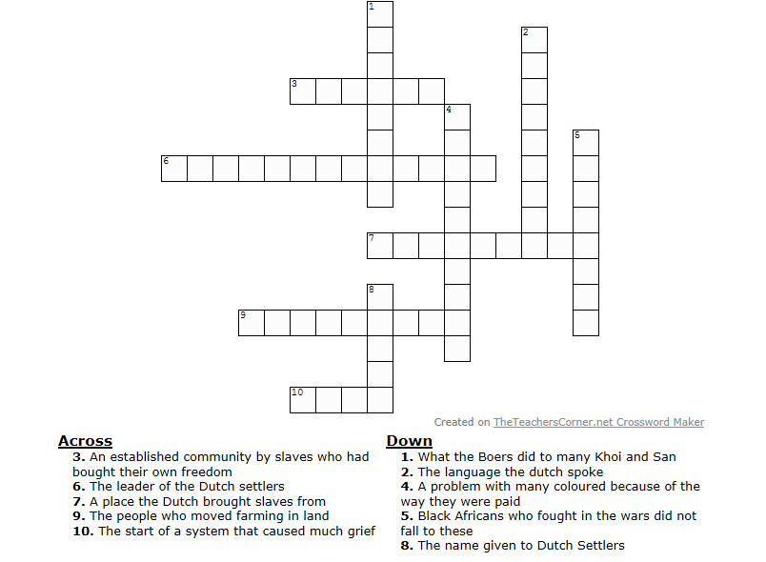
The British
If you have any comments or questions about the topics covered so far please write them here for your teacher.

By the late eighteenth century Britain’s Industrial Revolution was well under way and the British Empire in India was growing. Look at the map below; you should be able to see that Cape Colony was important to securing their route to India. The first occupation took place in 1795 and it became a British possession in 1806.
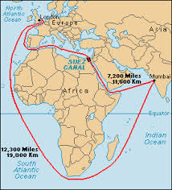
Key

Britain’s trade route to India before the Suez Canal was opened in 1857.

The impact of the British rule on the Boers from 1806 was two sided. Many Boers benefitted from links with the British trading empire and became prosperous sheep famers. There is evidence that many of those who set out on the Great Trek were poorer farmers, unable to benefit from British connections. Certainly Piet Retief was deeply in debt, and for him and those like him the Great Trek was a way of making a new start. Only about 15,000 Boers left the Cape between 1834 and 1850.
The people on the Great Trek did not find empty land. Certainly some was underpopulated as a result of difaquane/mfecane but that was only temporary. Black settlers soon moved onto the land claimed by the trekkers and farmed alongside them. Some trekkers tried to come to an arrangement with Xhosa chiefs to settle on their land by agreement. In other places trekkers were driven out by black settlers.
Nor was the land easy to farm. The first 120 settlers had to deal with droughts, locusts and crop diseases. The plan to grow crops in market gardens was ill thought out. The nearest market for fresh food was 900km to the west in Cape Town. By 1823 only a third of the original settlers were left. The survivors turned to business or trade – or began to move inland. This brought them into conflict with the black Africans of the interior. The British fought almost continuous frontier wars against the Xhosa and other peoples from 1819 to 1853. In the end, with horses, guns and trained soldiers the British were bound to win. A new British colony in Natal was founded in 1843. At first the British agreed that the Zulus should have the land to the north, but later they decided to seize Zulu lands. Although Chief Cetshwayo inflicted a famous crushing defeat on the British at Isandhlwana in 1897, the Zulus were broken in 1897.
Using the information above complete the following two tasks.

Categorising can be a useful historical skill. Fill in the following table categorising the information into the following
- Political –things to do with power
- Economic - things to do with money
- Technological – things to do with improving/making progess
- Environmental - things to do with the area you are in, sometimes but not always natural
Political | Economic | Technological | Environmental
You have now read the Afrikanners view of their own history alongside the stories of some of the other groups in South Africa. Can you identify and write in the correct box:
Ways in which the Afrikaaners’ story is not quite accurate

Ways in which the Afrikaaners’ story is not quite complete

Ways in which the Afrikaaners’ story is correct?

Key Words

Apartheid
Boer
Afrikaan
Reserves (in relation to the old African kingdom)
Great Trek
Broederbond
Mining capital
African National Congress (ANC)
Drum magazine
Homeland
Union of South Africa
Stayaway
Cold War
Cuban Missile Crisis
Liberation theology
Verkampte and verligte
Tricameral parliament
Laager mentality
Community (in relation to South Africa)
Necklacing
Witchcraft
CODESA
Federal system
Proportional representation
Party list (in relation to elections)

Topics for Wider research
- Suez Crisis, 1956
- Winnie Madikizela-Mandela (formerly Winnie Mandela)
- Oliver Tambo
- Walter Sisulu
- Nelson Mandela
- Steve Biko

