Theme of the Week – Peace

The Second Sunday of Advent is traditionally associated with Peace, and yet in our Gospel we hear John the Baptist ranting about vipers, axes, fire etc. Let’s have a look at what this means. In the first reading the prophet Isaiah addressed a discouraged Israel who was now in the third generation of the Babylonian exile and had lost all hopes. The prophet says that God has not forsaken his people and is about to bring them back to their land and inaugurate a kingdom of justice and **peace** where violence will be no more (the wolf will live with the lamb etc.). In the Gospel we see John the Baptist appearing in the desert and preaching a baptism of ‘conversion’. First of all, the desert has a theological significance; it is the place where we can only bring what is essential, where there is no rich or poor, where there is silence and where we can encounter God like Moses and Abraham did.

**In a noisy life buzzing with tweets, posts, opinions, can we create a little desert to give God a chance to speak to us?**

In the desert we are called to conversion. In the Old Testament this word meant ‘going back to God’, whereas in the New Testament (and in our Gospel) it means **CHANGE ONE’S MIND.** Why change our mind? The Baptist tells us: **Because the kingdom of heaven is at hand**, and unless we change the way we think, we won’t be able to welcome it and be part of it. There is here a contrast between the kingdom of this world and the kingdom of God. The former is a kingdom of violence, of selfishness and self-advancement, a kingdom prevarication, money, career etc. The kingdom of Heaven is a kingdom of brotherhood, justice and peace.

**What are the desires of your heart? Would you welcome the kingdom of heaven or would you rather stay in the kingdom of this world?**

There is a specific reason why John placed himself on the river Jordan to baptise: that was the very same place where Israel entered the Promised Land when coming back from Egypt. John is proposing a counter-Exodus, where people come out of Jerusalem and all the false certainties of a false religion in order to start again by changing their mind. The God of the Pharisees (strict and legalistic) and the Sadducees (a tit-for-tat commercial God) is a distortion of the real God, who is love and mercy. John invites all those who thought they were secure because they ‘did’ religion to re-examine themselves and test whether they were really open to the new kingdom and willing to change their wrong patterns and habits in order to advance it.

**In Advent we prepare for the coming of this kingdom by examining ourselves, our life and our projects. Are they in line with God’s proposal, or are they centred on ourselves and our achievements? Are we Christians because we want a reward from God, or do we really believe in his proposal?**

Finally John warns those who pretend to be religious but in reality are bent on themselves, that when the new kingdom comes, all that does not produce good fruit will be burned and consumed. **PEACE** is one of these fruits, but what is peace? It is not simply the absence of war, and not something that can be imposed on peoples and nations. **True peace is the inner state of those who have accepted the new kingdom and its king, Jesus, the Prince of Peace**. Only those who are transformed by the proposal of Jesus can reach true peace, and only those who have peace within themselves can be promoters of peace in our school, in our families, in our nation and in the world.

**Do you want to be a channel of His Peace?**

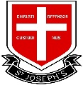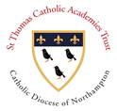

PEACE

*Weekly Reflections*

*4th December 2022*

**God our Peace, make us watchful and keep us faithful as we await the coming of your Son our Lord; that, when he shall appear, he may not find us sleeping in sin but active in his service and joyful in his praise; through Jesus Christ our Lord. Amen**

**Prayer for the Week**

**A reading from the Gospel of St Matthew (Mt 3:1-12)**

In those days John the Baptist came preaching in the wilderness of Judea, “Repent, for the kingdom of heaven is at hand.” For this is he who was spoken of by the prophet Isaiah when he said,

“The voice of one crying in the wilderness:

‘Prepare the way of the Lord;

make his paths straight.’”

Now John wore a garment of camel's hair and a leather belt round his waist, and his food was locusts and wild honey. Then Jerusalem and all Judea and all the region about the Jordan were going out to him, and they were baptized by him in the river Jordan, confessing their sins.

But when he saw many of the Pharisees and Sadducees coming to his baptism, he said to them, “You brood of vipers! Who warned you to flee from the wrath to come? Bear fruit in keeping with repentance. And do not presume to say to yourselves, ‘We have Abraham as our father’, for I tell you, God is able from these stones to raise up children for Abraham. Even now the axe is laid to the root of the trees. Every tree therefore that does not bear good fruit is cut down and thrown into the fire.

“I baptize you with water for repentance, but he who is coming after me is mightier than I, whose sandals I am not worthy to carry. He will baptize you with the Holy Spirit and fire. His winnowing fork is in his hand, and he will clear his threshing floor and gather his wheat into the barn, but the chaff he will burn with unquenchable fire.”

**Day 1**

The Second candle of the Advent Wreath symbolizes Peace.

* When you hear this word, what comes to your mind?
* What is peace?

**Day 5**

John the Baptist gave hope to all those coming to him saying that ‘the kingdom of heaven is near’. We have been talking about Christ the King and the Kingdom for a few weeks now.

* Can you articulate what the Kingdom of Heaven is about and how it differs from the kingdom of this world?
* Which one do you choose?

**Day 4**  
John the Baptist placed himself in the desert. In the Bible the desert is the place where, having left behind all that is unnecessary, we can encounter God and listen to him with a free heart. We live in a noisy world full of Tweets, posts, alerts…

* Do you ever create some desert/silence around you in order to collect your thoughts and be ready to listen to God? If so, please share.

**Day 3**

In our Gospel John the Baptist quotes Isaiah and asks people to ‘prepare a way for the Lord and make his paths straight’.

* What do you think that means?
* Can you find examples of a straight and a bendy path?

**Day 2**

**St Nicholas of Myra**

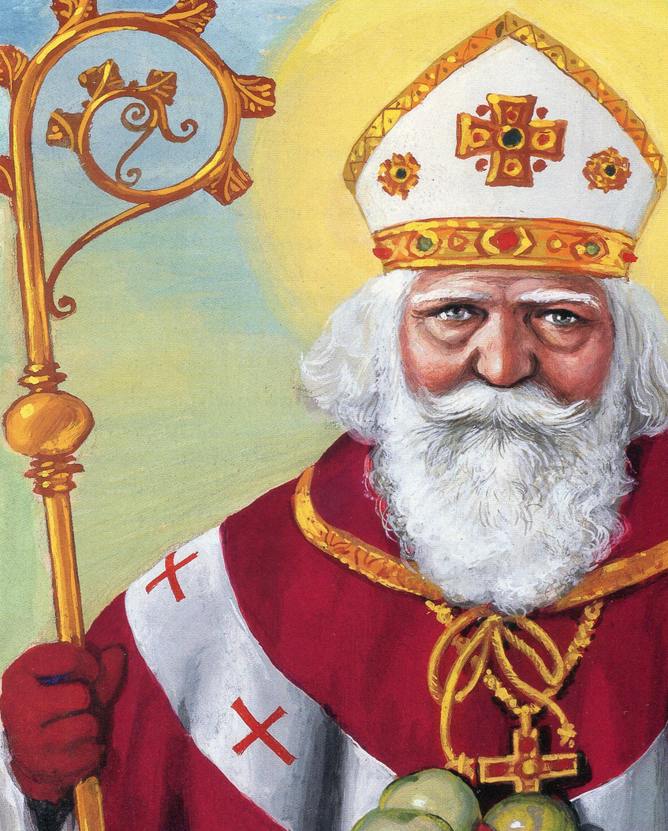

Did you know that ‘Santa Claus’ (Saint Nicolaus) really existed and was the bishop of Myra (Turkey)? According to legend, he once heard a poor man saying that he did not have enough money for his three daughters’ dowry. St Nicholas decided to help him but didn’t want any publicity, so he threw three bags of golden coins through the poor man’s windows. Hence the tradition of Father Christmas bringing gifts on Christmas Eve.